Scouting For Food
By
Ken Ross and David Hall

- When does this event take place? SFF occurs somewhere around the end of February each year.
- Where to go for information? http://npd.richstuff.net/?q=node/1090 and http://www.bsatroop540.org/SFF/
- When should we start to get organized? No later than 1 month ahead of the event our SFF POC should drum up support of the Scouts and parents at Den and Pack meetings. Once the participants have been recruited, each parent/scout team should be assigned a specific neighborhood to cover within P618s designated SFF territory.
- Preliminary preparations. Approximately 1400 door hangers must be “punched” and labeled in the weeks leading up to the event. In the past this has been done at the Pinewood Derby. The SFF grocery bags are distributed in bulk at the District Roundtable a couple of weeks prior to ‘D-Day’ (Distribution Day). It will then be necessary for the SFF POC to make sure that the correct number of hangers and bags are paired up according to the number of homes to be covered by the scout/parent team in a given neighborhood.
- Where/when do we meet for the “Bag Drop”? We meet up at the Clemens Crossing Elementary School parking lot at 9:00 AM on the day of the “bag drop”. Provided there are enough teams, distribution should not take more than an hour.
- Pick-Up Day. Have the parents and Scouts pick up bags on their designated routes starting at 9:00 AM the Saturday after the “Bag Drop”. It's important that they not pick up early as the instructions to the homeowners indicate that they need to have it out by 9:00AM.
- Where do we take the food once it's collected? In 2007, we donated to the Howard County Food Bank. You have to fill out a form : http://www.bsatroop540.org/SFF/FoodDriveForm.pdf and take it with you when you drop off food. It's located at the loading dock of the building behind the St. Johns Baptist church. (The church looks like an office building and its front is on Rt. 108). The address of the location is:
8920 Rt. 108
Columbia, MD
410-313-6185
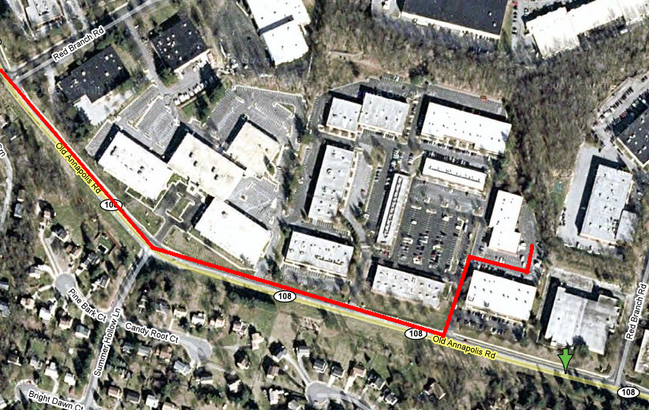

- Pack 618 SFF Area. The map is located at: http://web.mac.com/rhotonds/SFF/Packs_files/P618.pdf
Here's the map that we used in 2008:

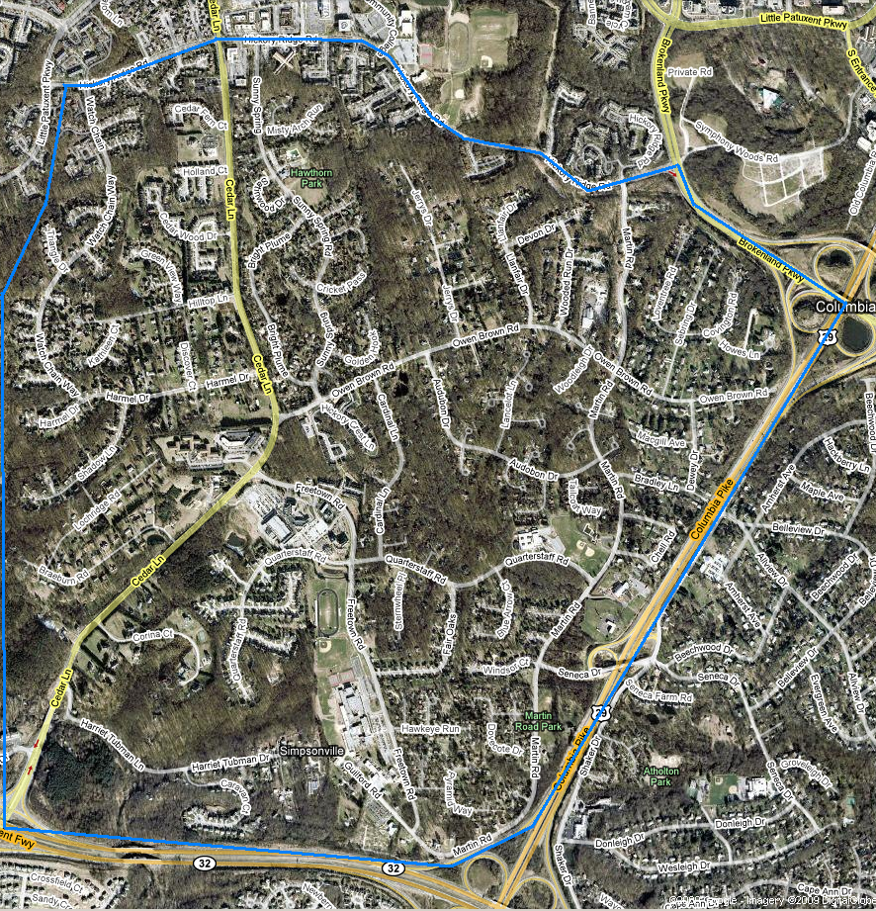
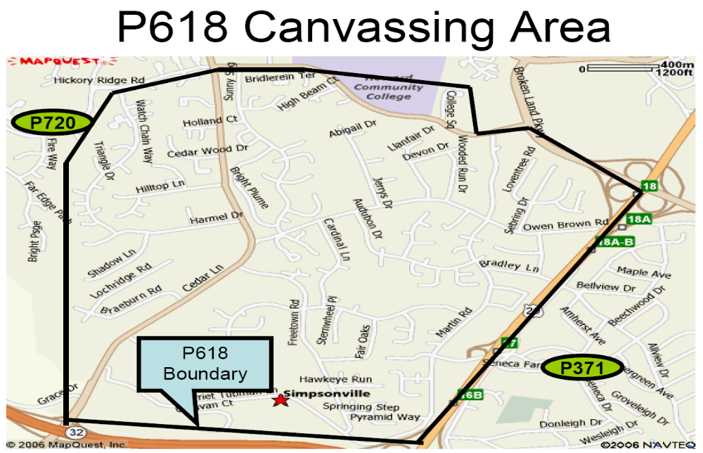
- Collecting the bags of food – We meet at the Clemens Crossing parking lot the Saturday after the “bag-drop” to collect the food that was donated. We count the bags that come in from each section of our assigned area (this is so we can try to determine where our most fruitful areas are located) and then load them into vehicles for transport to the donation center.
- After-Action Report. Once the event is complete, fill out an “After Action” form by going to: http://web.mac.com/rhotonds/SFF/ and clicking on the “After Action Form” link.
- Lessons learned from previous years:
- Print large, bright labels that not only have our pack info, but concise instructions on what to do and where the food goes (Howard County Food Bank this year). The feeling is that people probably are not reading the tiny print on the bags to find out what this is about.
- Attach the bags/hanger with a rubber band or twist-tie. Many of the door handles are not typical round handles and it's difficult to attach the bag/hanger securely. I think that a lot of the bags get blown away and become unsightly trash blowing through the neighborhoods. NOT the type of operation that we should be providing! For every bag that blows away, that's one less opportunity to retrieve a filled bag of canned goods.
- Just provide door hangers and not bags. The feeling is that everyone has a ton of plastic shopping bags already, so why give them another? This would actually be a form of recycling. As long as we put out a hanger with clear instructions, I think that this would work out nicely.
- If we're still going to use bags, we need to somehow ensure that there are enough hangers given to each person distributing bags. Some ran out of hangers. Some ran out of bags and had extra hangers. We either need to just do hangers or pre-divide the bags and hangers so that we aren't trying to do it in the parking lot.
- Have the maps drawn up ahead of time with SHORT routes. If there aren't enough people for the number of maps, we can always give more than one route in the same area to each person. This again cuts down on parking lot confusion.

Lessons from 2009
- Possibly prepare the bags ahead of time for ease of hanging them on "game-day",
- Rubber bands work on all types of doors and don't allow wind to blow hangers away so easily,
- Make better maps that show housing-density so that we can more effectively cover our areas,
- Offer some incentive for the boys who participate (maybe set a goal?),
- Possibly invite Girl Scout troops to help,
- Reminder-signs at entrances to neighborhoods,
- Knock on doors when no bag is present (time-consuming & aggressive, but very effective)

